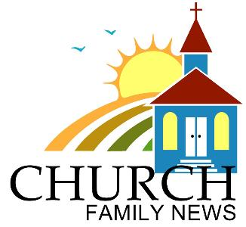

July 9, 2017

Norway STM (September 8-17, 2017)
NCAC will send a STM team to Bergen & Oslo, Norway this September. The team will lead the Mission Conferences in the Chinese Churches of both cities, and work with Pastor Ivy to mobilize church members for local mission in their cities and other surrounding cities in the Scandinavian region.

Joint Missions Convention (JMC)
http://englsih.ccaca.org/jmc/
Joint Missions Convention (JMC) will be held at Hamilton this year between August 4 and 7 (Civic Holiday long weekend)
Theme: From the DEEPER LIFE comes the OVERFLOWING LIFE.
Speaker: Rev. Dr. Gordon Smith - President and Professor of Systematic and Spiritual Theology of Ambrose University and Seminary in Calgary.
NCAC had submitted the collected forms & camp fees to CCACA. JMC registration is still open till June 30 and please contact Raymond Kwong of CCACA to complete the registration.

July 9, 2017

Norway STM (September 8-17, 2017)
NCAC will send a STM team to Bergen & Oslo, Norway this September. The team will lead the Mission Conferences in the Chinese Churches of both cities, and work with Pastor Ivy to mobilize church members for local mission in their cities and other surrounding cities in the Scandinavian region.

Joint Missions Convention (JMC)
http://englsih.ccaca.org/jmc/
Joint Missions Convention (JMC) will be held at Hamilton this year between August 4 and 7 (Civic Holiday long weekend)
Theme: From the DEEPER LIFE comes the OVERFLOWING LIFE.
Speaker: Rev. Dr. Gordon Smith - President and Professor of Systematic and Spiritual Theology of Ambrose University and Seminary in Calgary.
NCAC had submitted the collected forms & camp fees to CCACA. JMC registration is still open till June 30 and please contact Raymond Kwong of CCACA to complete the registration.

July 9, 2017

Norway STM (September 8-17, 2017)
NCAC will send a STM team to Bergen & Oslo, Norway this September. The team will lead the Mission Conferences in the Chinese Churches of both cities, and work with Pastor Ivy to mobilize church members for local mission in their cities and other surrounding cities in the Scandinavian region.

Joint Missions Convention (JMC)
http://englsih.ccaca.org/jmc/
Joint Missions Convention (JMC) will be held at Hamilton this year between August 4 and 7 (Civic Holiday long weekend)
Theme: From the DEEPER LIFE comes the OVERFLOWING LIFE.
Speaker: Rev. Dr. Gordon Smith - President and Professor of Systematic and Spiritual Theology of Ambrose University and Seminary in Calgary.
NCAC had submitted the collected forms & camp fees to CCACA. JMC registration is still open till June 30 and please contact Raymond Kwong of CCACA to complete the registration.

