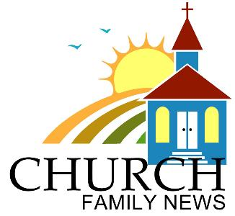

March 5, 2017

Helping the Children on Sunday

ChMT is in need of helpers to cook breakfast for the children class in July. If you can help out, please contact Leah Chan directly to let her know of your availability.

Joint Missions Convention (JMC)

Chinese Alliance Churches across Canada will be gathered for the Joint Missions Convention (JMC) to be held at Hamilton this year between August 4 and 7 (Civic Holiday long weekend)

Theme: From the DEEPER LIFE comes the OVERFLOWING LIFE.

Speaker: Rev. Dr. Gordon Smith - President and Professor of Systematic and Spiritual Theology of Ambrose University and Seminary in Calgary.

Deadline for NCAC Group Registration: April 16 (Easter Sunday).

Contact: Tim Kwok

March 5, 2017

Helping the Children on Sunday

ChMT is in need of helpers to cook breakfast for the children class in July. If you can help out, please contact Leah Chan directly to let her know of your availability.

Joint Missions Convention (JMC)

Chinese Alliance Churches across Canada will be gathered for the Joint Missions Convention (JMC) to be held at Hamilton this year between August 4 and 7 (Civic Holiday long weekend)

Theme: From the DEEPER LIFE comes the OVERFLOWING LIFE.

Speaker: Rev. Dr. Gordon Smith - President and Professor of Systematic and Spiritual Theology of Ambrose University and Seminary in Calgary.

Deadline for NCAC Group Registration: April 16 (Easter Sunday).

Contact: Tim Kwok

March 5, 2017

Helping the Children on Sunday

ChMT is in need of helpers to cook breakfast for the children class in July. If you can help out, please contact Leah Chan directly to let her know of your availability.

Joint Missions Convention (JMC)

Chinese Alliance Churches across Canada will be gathered for the Joint Missions Convention (JMC) to be held at Hamilton this year between August 4 and 7 (Civic Holiday long weekend)

Theme: From the DEEPER LIFE comes the OVERFLOWING LIFE.

Speaker: Rev. Dr. Gordon Smith - President and Professor of Systematic and Spiritual Theology of Ambrose University and Seminary in Calgary.

Deadline for NCAC Group Registration: April 16 (Easter Sunday).

Contact: Tim Kwok

